**ABSTRACT**

**HYDROCHLORIC ACID MONITOR PLACEMENT USING TRAJECTORY MODELING NEAR THE GREAT SALT LAKE**

Alexis Wilson, Nancy Daher Ph. D., Chris Pennell

Environmental Scientist, Utah Division of Air Quality

February 9th, 2018

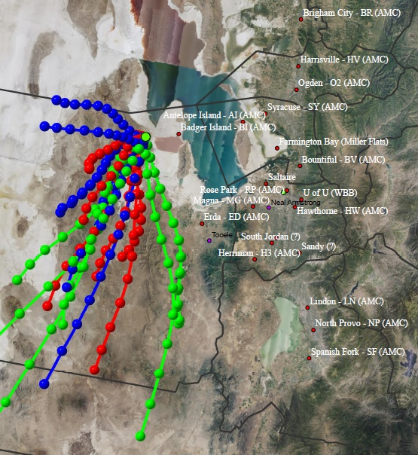 Particulate matter less than 2.5 microns in diameter (PM2.5) poses an increasingly prominent public health hazard during wintertime inversions in the Great Salt Lake area and along the Wasatch Front. A 2013 study by Kerry et al demonstrated that 10-15% of the total PM2.5 mass along the Wasatch Front consists of ammonium chloride, a secondary PM2.5 aerosol. Ammonium chloride (NH4Cl) forms when ammonia (NH3), a gaseous byproduct of agricultural activity, reacts with gaseous hydrochloric acid (HCl). Industry surrounding the Great Salt Lake, such as a large magnesium refinery and smaller oil refineries, is a potential source of gaseous HCl. To better understand sources of high concentrations of ammonium chloride, the Utah Division of Air Quality proposes to place several air monitors downwind of potential HCl emitters. This study employs a Hybrid Single Particle Lagrangian Integrated Trajectory Model (HYSPLIT) in conjunction with wind rose analysis to determine historical wind trajectories that may carry harmful PM2.5 precursors into the Salt Lake Valley. Based on model output, several potential locations for monitor placement are proposed.